**KWAME NKRUMAH UNIVERSITY OF SCIENCE AND TECHNOLOGY**

**CHEMICAL ENGINEERING DEPARTMENT**

**CHE 158: INTRODUCTION TO INFORMATION TECHNOLOGY**

**INSTRUCTOR:** Dr. (Mrs.) Mizpah A. D. Rockson

LECTURE 3: **BASIC APPLICATION SOFTWARE**

**Learning Objectives**

At the end of the lecture the student is expected to be able to do the following:

1. Identify general-purpose applications.
2. Describe word processors, spreadsheets, presentation programs, and database management systems.
3. Identify specialized applications.
4. Describe graphics programs
5. Identify software suites.
6. Describe office suites, cloud suites, specialized suites, and utility suites.

Not long ago, trained specialists were required to perform many of the operations you can now do with a microcomputer. Secretaries used typewriters to create business correspondence. Market analysts used calculators to project sales. Graphic artists created designs by hand. Data processing clerks created electronic files to be stored on large computers. Now you can do all these tasks—and many others—with a microcomputer and the appropriate application software.

Competent end users need to understand the capabilities of basic application software, which includes word processors, spreadsheets, database management systems, and presentation programs. They need to know about integrated packages and software suites. Basic application software are also known as **general-purpose applications**.

**3.1 Common features**

Some features are common to all kinds of applications.

**-Version and release**

Software are continually being improved and revised. When a software first appears, it is assigned the number 1.0. As the software improves, the number changes. The number before the period refers to the **version**; the number after the period refers to the **release**. Changes in version numbers indicate major changes; changes in release refer to minor changes.

**-Graphical user interface (GUI)**

A **user interface** is the portion of the application that allows you to control and to interact with the program. Most applications use a **graphical user interface** **(GUI)** that displays graphical elements called **icons** to represent familiar objects and a mouse. The mouse controls a **pointer** on the screen that is used to select items such as icons.

Another feature is the use of windows to display information. A **window** is simply a rectangular area that can contain a document, program, or message. More than one window can be opened and displayed on the computer screen at one time.

Insertion point or cursor is a blinking vertical bar on the screen, but it can have other shapes as well. It shows where you can enter your next data. It can be moved around by the mouse or the directional arrow keys.

**-Menus**

Traditionally, most software programs, including those in Microsoft Office 2003, use a system of menus, toolbars, dialog boxes, and buttons. **Menus** present commands that are typically displayed in a **menu bar** at the top of the screen. When one of the menu items is selected, an additional list of menu options or a **dialog box** that provides additional information and requests user input may appear. **Toolbars** typically appear below the menu bar. They contain small graphic elements called **buttons** that provide shortcuts for quick access to commonly used commands.

Microsoft Office 2010 uses an interface introduced in Office 2007 that makes it easier for users to find and use all the features of an application. This new design introduces ribbons, tabs, galleries, and more.

* **Ribbons** replace menus and toolbars by organizing commonly used commands into a set of tabs. These tabs display command buttons that are the most relevant to the tasks being performed by the user.
* **Tabs** are used to divide the ribbon into major activity areas. Each tab is then organized into **groups** that contain related items. Some tabs, called **contextual tabs**, only appear when they are needed and anticipate the next operations to be performed by the user.
* **Gallaries** simplify the process of making a selection from a list of alternatives. This is accomplished by displaying small graphic representations of the alternatives.

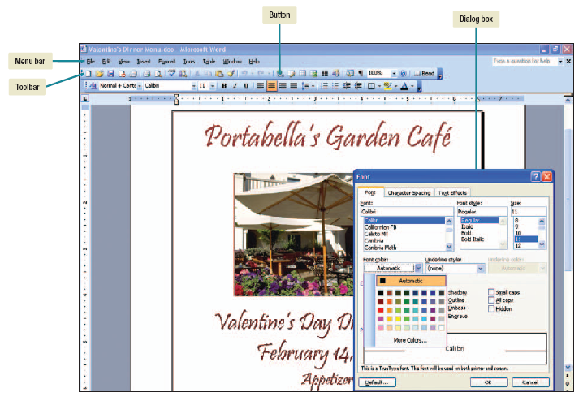

**Figure 3.1: Microsoft office word 2003 interface**

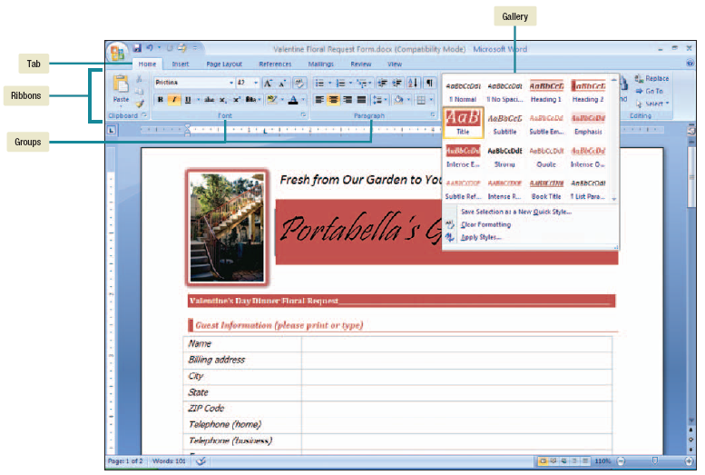

**Figure 3.2: Microsoft office word 2007 interface**

This new interface is the first major change in over a decade and promises to greatly improve user functionality and efficiency.

**3.2 Word processors**

Word processors create text-based documents such as reports, letters, memos, faxes, newsletters, manuals, brochures… They are used not only by secretaries, but extensively in managerial and professional life.

**Microsoft Word** is the most widely used word processor. Other popular word processors include **Corel WordPerfect** and **Apple Pages**.

**3.2.1 Common Features**

Word processors provide a variety of features to make entering, editing, and formatting documents easy.

**-Word wrap** feature automatically moves the insertion point to the next line oncethe current line is full. As you type, the words wrap around to the next line.

**-Editing or modifying a document**

**a. Thesaurus** provides synonyms, antonyms, and related words for a selected word or phrase.

**b. Find and replace** can quickly locate and replace selected words.

**c. Spelling and grammar checkers** look for misspelled words and problems with capitalization, punctuation,and sentence structure.

**-Formatting a document**

**a. Font and font size.** Font is the design of characters and the height/size of a character is the font size.

**b. Character effects** such as **bold**, ***italic***, **underline**, and **color** are used to enhance the appearance of characters.

**c. Style** enables users to quickly apply a predefined set of formatting characteristics to text in one easy step rather than individually selecting specific fonts, sizes, and formats.

**3.3 Spreadsheet**

Spreadsheet programs organize, analyze, and graph numeric data such as budgets and financial reports. Once used exclusively by accountants, spreadsheets are widely used by nearly every profession.

The most widely used spreadsheet program is **Microsoft Excel**. Other spreadsheet applications include **Apple iWork’s Numbers** and **Corel Quattro Pro**.

**3.3.1 Common Features**

Unlike word processors, which manipulate text and create text documents, spreadsheet programs manipulate numeric data and create workbook files.

**Workbook files** consist of one or more related worksheets. A **worksheet,** also known as a **spreadsheet** or **sheet,** is a rectangular grid of **rows** and **columns.** Columns are identified by letters and the rowsare identified by numbers. The intersection of a row and column creates a **cell.**

A cell can contain text or numeric entries. **Text entries** or **labels** provide structure to a worksheet by describing the contents of rows and columns.

A **numeric entry** can be a number or a formula. A **formula** is an instruction to calculate or process. **Functions** are prewritten formulas provided by the spreadsheet program that perform calculations such as adding a series of cells. A **range** is a series of continuous cells.

**Analytical graphs** or **charts** are visual representations of data in a spreadsheet. Spreadsheet can perform **recalculations** and **what-if-analysis**.

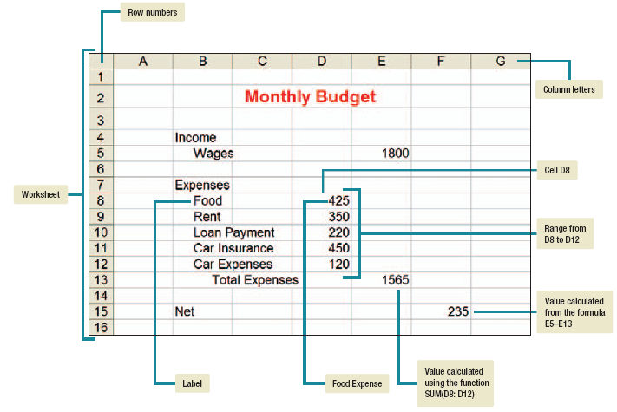

**Figure 3.3: Worksheet**

**3.4 Database Management Systems**

A **database** is a collection of related data. It is the electronic equivalent of a file cabinet. A **database management system (DBMS)** or **database manager** is a program that sets up, or structures, a database. It also provides tools to enter, edit, and retrieve data from the database. All kinds of individuals use databases to keep records of people, places, and things.

The most widely used database management system designed for microcomputers is **Microsoft Access**. Other database management systems include **Corel Paradox** and **dBASE**.

**3.4.1 Common Features**

The **relational database** is the most widely used database structure. Data is organized into related **tables.** Each table is made up of rows called **records** and columns called **fields.** Each record contains fields of data about some specific person, place, or thing.

A DBMS provides a variety of tools to create and use databases. A **sort** tool will quickly rearrange a table’s records according to a selected field. A **filter** tool will quickly display only those records meeting the conditions you specify.

The greatest power of a DBMS, however, comes from its ability to quickly find and bring together information stored in separate tables using queries, forms, and reports. A **query** is a question or a request for specific data contained in a database. Database **forms** look similar to traditional printed forms. These electronic forms are displayed on the computer monitor and typically reflect the contents for one record in a table. They are primarily used to enter new records and to make changes to existing records. Data from tables and queries can be printed in a variety of different types of **reports** from a simple listing of an entire field in a table to a list of selected fields based on a query involving several tables.

**3.5 Graphics**

Research shows that people learn better when information is presented visually.

There are 3 types of graphic programs:

(1) **Analytical graphics** are used to analyze data. Numerical data in tables are much more difficult to understand than charts. They come as part of spreadsheet programs like Excel.

(2) **Presentation graphics** are programs that combine a variety of visual objects to create attractive, visually interesting presentations. They are excellent tools to communicate a message and to persuade people. For example, marketing managers use presentation graphics to present proposed marketing strategies to their superiors. Salespeople use these programs to demonstrate products and encourage customers to make purchases. Students use presentation graphics programs to create high-quality class presentations.

**Features**

An electronic presentation consists of a series of **slides** or **pages.** Presentation programs include a variety of features to help you create effective dynamic presentations. **Templates** are professionally designed layouts with sample text. **Design templates** provide professionally selected combinations of color schemes, slide layouts, and special effects.

**Content templates** include suggested content for each slide. Other features include tools to select alternative color schemes and slide layouts, to create animated graphics and charts, and to help you rehearse the presentation.

More advanced features include the capability to use **animations,** special effects that add action to text and graphics on a slide. Additionally, **transitions** can be used to animate how the presentation moves from one slide to the next. Other features allow you to print slides, create speaker notes, and provide handouts for your audience.

The most widely used presentation graphics programs are:

* Microsoft PowerPoint
* Corel Presentation
* Lotus Freelance Graphics

(3) **Drawing programs for illustration** are used by people doing commercial art or drafting. A

Few of the many drawing programs available include:

* Adobe Illustrator
* Micrografx Designer
* Autocad
* Microsoft Visio, etc

**3.6 Integrated packages**

An **integrated package** is a single program that provides the ***functionality***of a word processor, spreadsheet, database manager, and more. The primarydisadvantage of an integrated package is that the capabilities of each functionare not as extensive as in the individual programs. The primary advantages are cost and simplicity. The cost of an integrated package is much less than the cost of the individualpowerful, professional-grade application programs.

Integrated packages are popular with many home users and are sometimes classified as **personal** or **home software.** The most widely used integrated package is **Microsoft Works**. **AppleWorks** is also widely used.

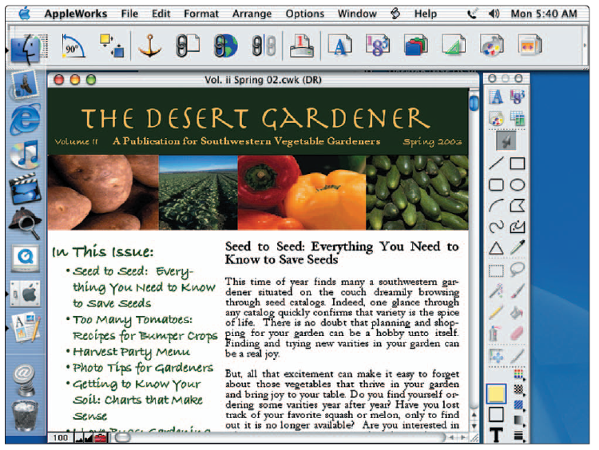

**Figure 3.4: Integrated package (Microsoft Works)**

**3.7 Software suites**

A **software suite** is a collection of separate application programs bundled together and made available as a group. While the applications function exactly the same whether purchased in a suite or separately, it is significantly less expensive to buy a suite of applications than to buy each application separately.

**3.7.1 Productivity suites**

**Productivity suites,** also known as **office software suites** or simply **office suites,** contain professional-grade application programs that are typicallyused in a business situation including a word processor, spreadsheet, database manager, and more. The best known is **Microsoft Office**. Other well-known productivity suites are **Apple iWork**, **Sun StarOffice**, **Corel WordPerfect Office Suite**, and **Lotus SmartSuite**.

Traditionally, when you purchase an office suite you are licensed to use the application and a copy of the software is stored on your computer. Recently, however, several alternative office suites have been made available for free as downloadable software. Popular downloadable office suites include **Star-Office**, **IBM Lotus Symphony**, and **OpenOffice**.

**3.7.2 Cloud computing**

**Cloud suites** or **online office suites** are stored at a server on the Internet and are available anywhere you can access the Internet. Documents created using online applications also can be stored online, making it easy to share and collaborate on documents with others. Popular online office suites include **Google Docs**, **Zoho**, and **ThinkSmart**.

**3.7.3 Specialized and utility suite**

**Specialized suites** focus on specific applications. These include graphics suites, financial planning suites, and many others.

**Utility suites** include a variety of programs designed to make computing easier and safer. Two of the best known are **Norton SystemWorks** and **Norton Internet Security Suite**.

**3.8 Sharing data between applications**

Many times it is convenient to share data between applications. For example, when writing a report, it may be useful to include a chart from a spreadsheet or data from a database. Data created by one application can be shared with another application in a variety of different ways, including copying and pasting, object linking, and object embedding.

**3.8.1 Copy and paste**

When you copy an item from a file, you can paste it into another file even in another application. This is a static copy in that any changes to one file will not reflect in the other.

**3.8.1 Object linking and embedding (OLE)**

Object linking and embedding is a powerful feature of many application programs. It is a way of dynamically sharing and exchanging data between applications. For example, you could create a chart in Excel and then use it in a Word document. Whenever the text document is opened, the most up-to-date version of the chart would appear in the document.

With **object linking**, a copy of the object from the **source file** (the file containing the object) is inserted in a **destination file** (the file receiving the object) and a **link** between the two files is established. If a change occurs in the source file that affects the object, the link between the two files will automatically update the destination file.

With object embedding, the object from the source file is embedded or added to the destination file and becomes part of the destination file. The embedded object can be edited from within the destination file. However, changes you make to the embedded object are not reflected in the original file.